August 18, 2009

Dear Author,

Congratulations! Your paper #88, Synthesizing Complementary Circuits Automatically, was accepted for the 2009 International Conference on Computer-Aided Design. This letter contains the instructions for preparing and submitting your final camera-ready paper.

Please take a couple of moments to carefully read this letter, as it contains critical information regarding your submission and registration. BE SURE to note the Key Dates listed herein.

ICCAD strives to maintain a high-quality technical program, and your paper was one of only 115 papers accepted out of 438 papers submitted, a 26% acceptance rate. The reviewers and Program Committee chose your paper because it will substantially add to the content and quality of the conference. Please consider the reviewers’ comments included with your acceptance email when you finalize your paper.

Attached is an acceptance confirmation form. Please fill out this form very carefully since this is EXACTLY the way your paper will be described in the conference programs and website. Using an editor, fill out the exact title and author names, including affiliations, then return to Debi Johnson, debi@mpassociates.com as an attachment. Then print it and either FAX it or email a scanned copy. The machine readable copy, and the signed confirmation form are due in the ICCAD office by August 31, 2009.
- Fax number: 303.530.4334 Phone: 303.530.4562
- Email: debi@mpassociates.com

By submitting a paper, you have agreed to prepare a version of your paper for the Proceedings, have a presenter at the conference, and to provide a high-quality presentation.

Your final paper for the proceedings should include all items covered in your original submission, updated as appropriate, based on feedback from the reviewers. You may correct any mistakes and update experimental results with current information. However, any changes that significantly degrade the quality of the paper are not permissible. Examples of such changes include, but are not restricted to: the elimination of any of the major sections used by the reviewers and Program Committee to evaluate your paper, or the removal of the experimental results section.

PROCEEDINGS INSTRUCTIONS

ACM will hold the copyright for ICCAD 2009. ICCAD will produce a CD-ROM of the proceedings. You must submit an ACM copyright form, a copy of which is attached, and also available at http://www.acm.org/publications/CopyReleaseProcFinal-6.2.09.pdf

This form must also be signed, so you will need to either FAX it or email a scanned copy. The signed confirmation form is due in the ICCAD office by August 31, 2009.
- Fax number: 303.530.4334 Phone: 303.530.4562
- Email: debi@mpassociates.com

You are allotted four pages in the proceedings. If you would like to add pages, (MAXIMUM of four additional pages) the cost is $125 per extra page. The form for this payment is included. The deadline for your final manuscript is September 8, 2009. Submissions not received by September 8 will NOT be published in the ICCAD Proceedings.

You will need to submit a camera-ready copy of your paper in PDF format. All PDF files must be produced using ACM templates AND be in compliance with ACM and IEEE PDF standards. This will be strictly enforced!

Before you submit, you must check your PDF file for adherence to IEEE library standards. Go to http://www.pdf-express.org and follow the instructions there. Our conference ID is iccad09. This site contains further instructions for checking your PDF before you submit it to the EasyChair site.
Once the PDF Express site is available, you will receive another email with instructions on how to upload your final paper to the EasyChair site.

NOTE: There is a maximum of three tries to check your PDF file to see if it is IEEE compliant.

Once your paper adheres to the ACM templates and passes the IEEE PDF checks, you must submit it to the EasyChair system which you used to submit your preliminary version.

The ICCAD Proceedings will be available via the ICCAD archive website after the conference. This will help promote your ideas to a larger audience. No additional work for this is required on your part.

SPEAKER'S GUIDE
Papers with long presentations have been allocated 25 minutes for presentation and 5 minutes for questions and answers. Short presentations will be 12 minutes presentation and 3 minutes Q&A.

PowerPoint XP files are the only acceptable visual aid this year at ICCAD. ICCAD will provide a PC with Windows XP, PowerPoint and an LCD projector. There will also be appropriate connections for both PC and MAC laptop computers. ICCAD is not responsible for loading your slides on the computer at the conference. Be sure to bring a final version of your PowerPoint presentation on a USB thumb drive (preferred) or a CD-ROM.

Your paper is tentatively scheduled to be presented in Session 5C on Tuesday at 10:30am. Please be sure to check the final program to confirm your session date and time.

Review of your PowerPoint Presentation Slides
A complete copy of your PowerPoint slides must be sent to your session moderator by October 3 for review. They will provide suggestions to make your presentation a professional one. Be sure to review the Key Dates listed below for information regarding the review of your PowerPoint slides before the conference. Instructions and contact information will be sent to you via email on September 26.

REGISTRATION
At least one author per accepted paper must register and pay a $400 registration fee. Failure to register will result in your paper being removed from the conference proceedings. IEEE reserves the right to exclude a paper from distribution after the conference (e.g., removal from IEEE Xplore) if the paper is not presented at the conference. Registration instructions will be sent by to you soon.

VISAS
Recently, U.S. embassies have experienced longer delays in the issuance of visas. Due to increased security measures in the United States, an updated visa might be required. Thus, it is recommended that you check to be sure your visa will allow entry to the United States. We strongly recommend that you start your visa process IMMEDIATELY. To request an invitation letter, please email Nannette Jordan at nannette@mpassociates.com with your name, mailing address, phone, fax and paper title.

Key Dates

August 31, 2009: Fax or email the Acceptance Confirmation form to the ICCAD office.
FAX: 303-530-4334 or email to debi@mpassociates.com
Be sure to clearly indicate any changes or corrections, as this is
the information that will appear in the final program.
Please make sure all names and affiliations are correct, and include
city, state, and country.+

Sept 8, 2009: The PDF file for the CD-ROM Proceedings must be received. Submissions not received by Sept 8 will not be published in the
ICCAD proceedings.

October 3, 2009: Email an initial version of your PowerPoint presentation to your session moderator.

October 14, 2009: If you have submitted your PowerPoint slides to your moderator on time, you should receive feedback on your slides from your moderator by this date.

November 2, 2009: The conference opens at the DoubleTree Hotel in San Jose, California, USA. Be sure to bring a final version of your PowerPoint presentation on a USB thumb drive (preferred) or a CD-ROM.

All technical sessions will take place at the DoubleTree Hotel in San Jose, CA. We suggest you make your travel and room arrangements early since the hotel can sell out fast. You are required to attend the Speaker's Breakfast at the DoubleTree on the day of your presentation. This breakfast is served at 7:30am on the following days: Monday, November 2, Tuesday, November 3, and Wednesday, November 4 in the Siskiyou Room at the hotel.

WHY STAY AT THE CONFERENCE HOTEL? rate for presenters: $129
It's the center of conference activity, that's why! You will be able to network easily with other attendees, and you don't need to worry about transportation each day to get to the program and functions. The DoubleTree hotel is the conference headquarters for ICCAD this year.
The ICCAD office will email you a link to book your hotel room at the DoubleTree Hotel San Jose. ICCAD has negotiated a special rate for presenters.

Thank you again for your contribution to ICCAD. We are looking forward to seeing you in San Jose, California, November 2-5, 2009.

Sincerely,

Louis Scheffer
Technical Program Chair, ICCAD 2009

Joel Phillips
Vice Technical Program Chair, ICCAD 2009
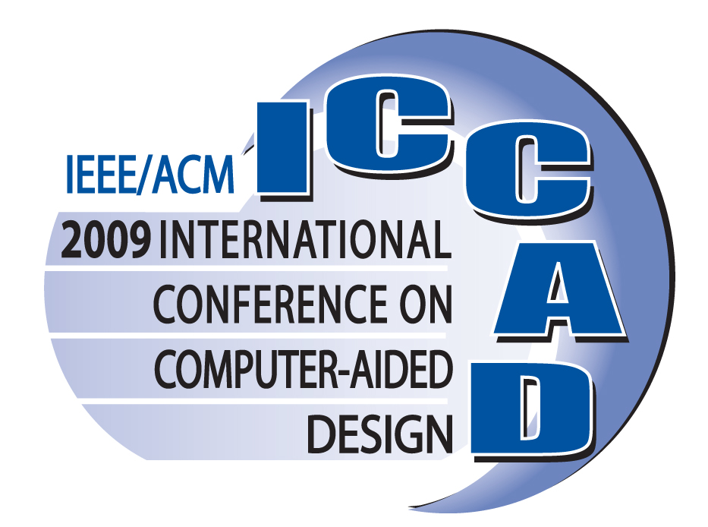

ICCAD EXTRA PAGES IN CONFERENCE PROCEEDINGS

Author Name: _ShengYu Shen_____________________________________________________________

Session #: ____5C _____________________________________________________________

Paper ID#______88____________________________________________________________

Number of Extra Pages: __4___________________________________ ($125 per extra page)

Total Cost: ____$500____________________________

Email address to send receipt to you by September 10, 2009: ___shengyushen@gmail.com____________

Payment Information

Card Holders Name (please print): ______SHEN SHENG YU_______________________________

Card Holder Signature: _________________________________________________________

Credit Card Type: American Express MasterCard Visa

Credit Card Number:____4270 2004 0005 8179_____Exp. Date ___2011/04_________

Security Code: ___080_______ Visa/Mastercard code is 3-digits located on back of the card.
American Express is 4-digits located on front right hand corner.

ICCAD Invoice
ICCAD-2009 Extra Pages
Please fax or email this form to Sandy Owens at 303-530-4334 or sandy@mpassociates.com

ICCAD 2009 Confirmation Form

I hereby confirm that I will publish and present my paper at ICCAD 2009.
Replace the sample information below with the correct information EXACTLY as it should appear in the program:
Paper ID: 999
Title: Sample Title goes here
Author(s): Mark the corresponding author with a c, the speaker with an s. If the same author is both, use (cs).
(c) John J. Example, Miskatonic University, Arkham, Massachusetts, USA
(s) Author 2, Cowboy State University, Denver, Colorado, USA
Author three, International university, city, state, country
I have checked that
- The title is exactly as I wish it to appear in the program, and
- All names and affiliations are correct, and include city, state, and country.
- The corresponding author and speaker are correct
I also confirm we have organizational approval for proceedings publishing, will prepare a paper for the proceedings, and will have a presenter at the conference
Please complete this form in machine readable form and email it to Debi@mpassociates.com. Then print it, sign it, and either FAX it or send a signed copy to Debbie.

Signature ______________________________ Date _________________

- Fax number: +1.303.530.4334 Phone: +1.303.530.4562
- Email: debi@mpassociates.com
.

